Laboratory Demo 3 – Preliminary version
Analysis of 5G NR signals using LITEPOINT IQgig-5G two-port tester
EE161: Digital Communication Systems
San José State University

- Introduction

In this lab demo, we use LITEPOINT’s IQgig-5G, the first fully integrated, single box, multiband mmWave test solution, designed for 5G NR user equipment (UE) and small cells testing across all 5G FR2 frequencies within a 23-45GHz range. All signal generation, analysis, processing, and RF front-end switching is self-contained inside a single chassis.

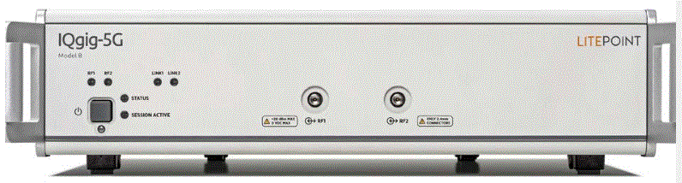

Calibrated RF ports enable direct connection (via a cable) for simple text fixture setups:

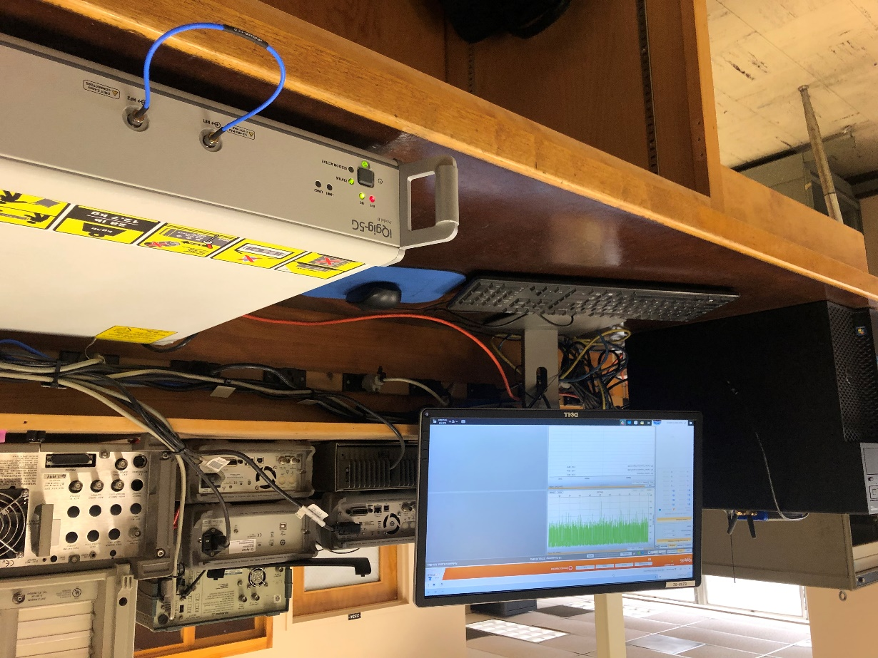

- Procedure

  - Start a web browser and open address 192.168.100.254

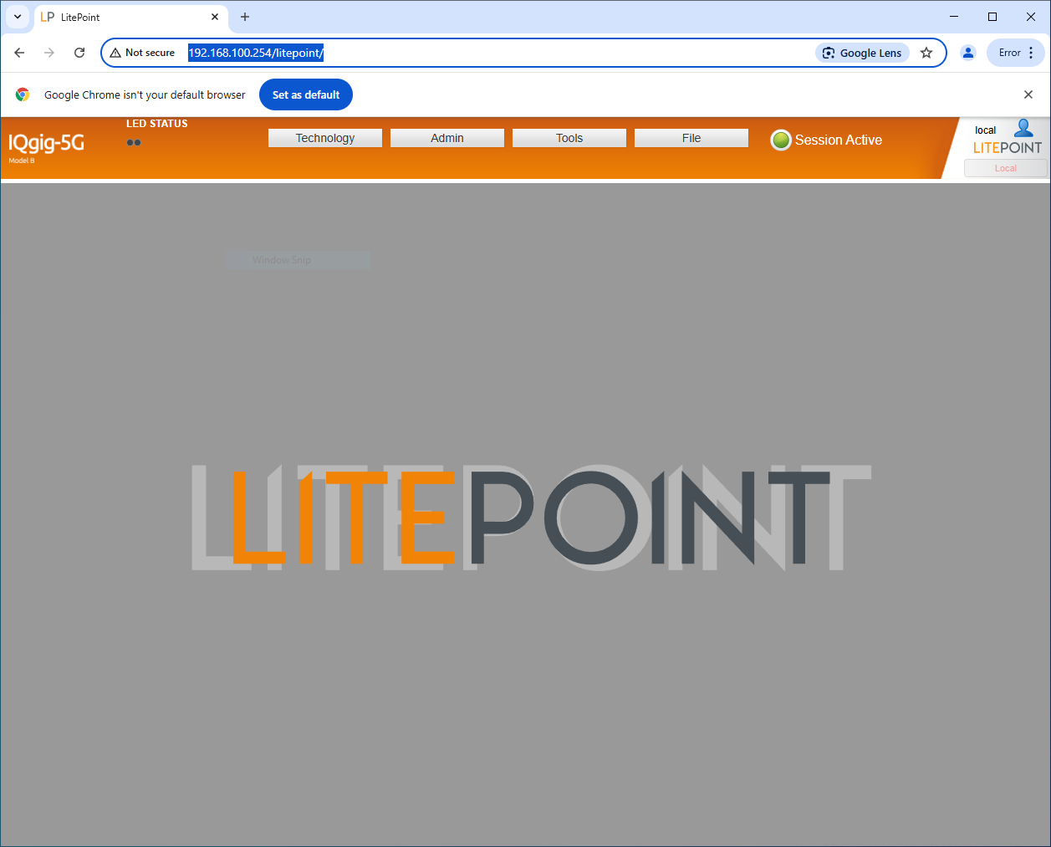

2.2 Technology -> 5G

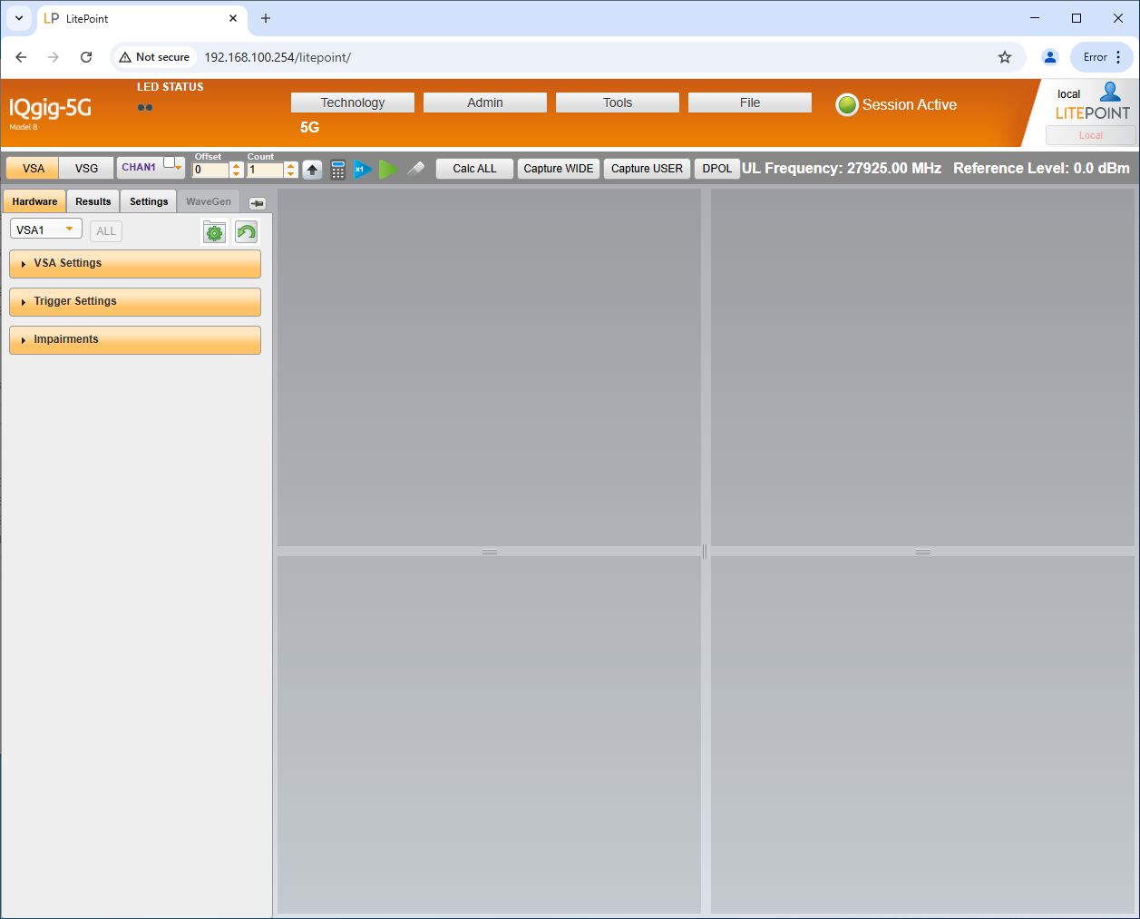

  - Assign RF ports: RF1A -> VSG and RF2A -> VSA

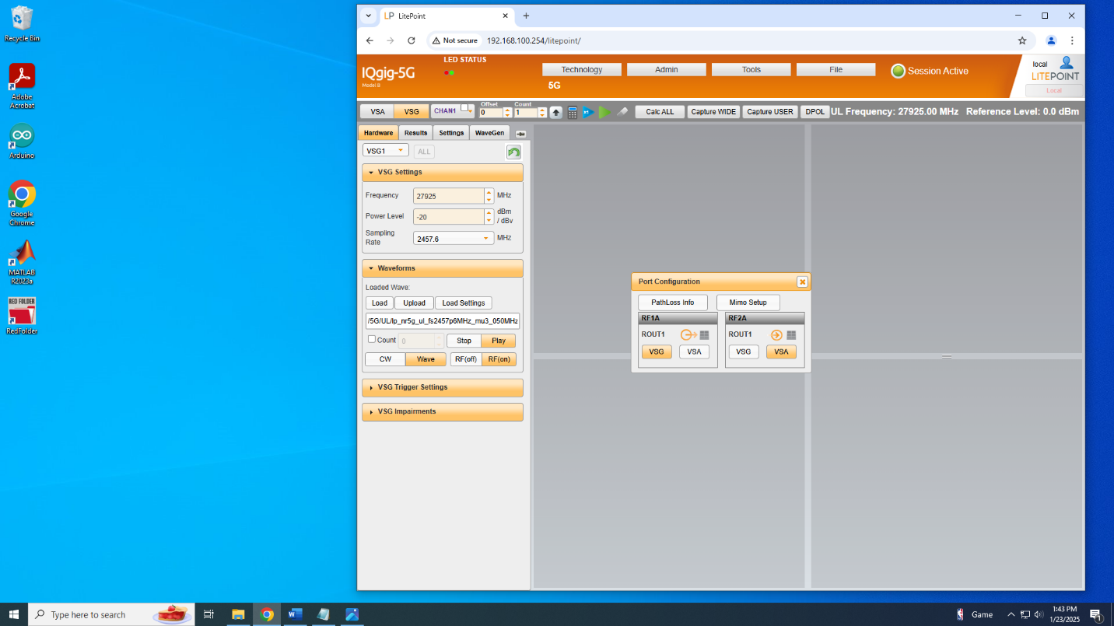

  - Tools - > SCPI console: Copy and paste the contents of text file SCPI_command.txt into console and hit return. Below are the SCPI commands as a reference:

ROUT1;PORT:RES:ADD RF1A,VSG1; ROUT1;PORT:RES:ADD RF2A,VSA1;
VSG1; WAVE:LOAD '/5G/UL/lp_nr5g_ul_fs2457p6MHz_mu3_050MHz_CP_rbd032_rbo000_01cc_256QAM_CONT.iqvsg'
CHAN1; VSG1;WAVE:EXEC ON
CHAN1; VSG1;POW:lev -20
CHAN1; VSA1;CAPT:TIME 0.002
5G; MRST; CONF:FREQ:RANG FR2; CONF:DIR UL; CONF:STAN NR; CONF:SDET:CCAC ONE; CONF:SDET:GAP 50us; CONF:SDET:THR -20; CONF:CCDF:CALC:SLOT ON; CONF:SDET:NSFR 1; CONF:SFOR CONT; CONF:TXQ:TRAC:PHAS ON; CONF:TXQ:TRAC:AMPL ON; CONF:TXQ:TRAC:SCL OFF; CONF:CALC:SACQ ON; CONF:TXQ:EACQ OFF; CONF:IQOF:REM ON; CONF:MIMO:MODE "CONDUCTED"; CONF:MIMO:SEL "SISO"; CONF:PCOM:SEL AUTO; CONF:CCAC:FTYP REL; CONF:SPEC:OBW:SPAN 50000000; CONF:CCAR:CC1 ON; CONF:NUM:CC1 3; CONF:CBW:CC1 50000000; CONF:MOD:CC1 256QAM; CONF:PCOM:CC1 OFF; CONF:CCAC:CFR:CC1 0; CONF:NID:SCID:CC1 0; CONF:SCID:CC1 0; CONF:NID:DMRS:CC1 0; CONF:DMRS:CDMD:CC1 AUTO; CONF:DMRS:CDMU:CC1 1; CONF:DMRS:PBO:CC1 0; CONF:DMRS:DET:CC1 USER; CONF:DMRS:SLOT:CC1 (0, 1, 2, 3, 4, 5, 6, 7); CONF:DMRS:CFGT:CC1 1; CONF:DMRS:ANT:PORT:CC1 (0); CONF:NLAY:CC1 1; CONF:NANT:CC1 1; CONF:CBXM:CC1 OFF; CONF:TPMI:CC1 0; CONF:DMRS:SEL:CC1 3GPP; CONF:DMRS:MTYP:CC1 TYPE_A; CONF:DMRS:MLEN:CC1 1; CONF:DMRS:TYPE:APOS:CC1 2; CONF:DMRS:ADDL:APOS:CC1 2; CONF:DMRS:TFPC:CC1 OFF; CONF:UDSF:CC1 3GPP; CONF:UDSF:3GPP:CC1 1; CONF:PTRS:CC1 OFF; CONF:RBC:CC1 USER; CONF:RBC:RBOF:CC1 0; CONF:RBC:RBD:CC1 32;
CHAN1; VSA1;INIT
5G; calc:txq:cc1 0,1; calc:pow:cc1 0,1; calc:spec 0,1

  - Run / Run single

  - VSA – Results – Drag and drop (1) Constellation, (2) Power vs Time and (3) Spectrum

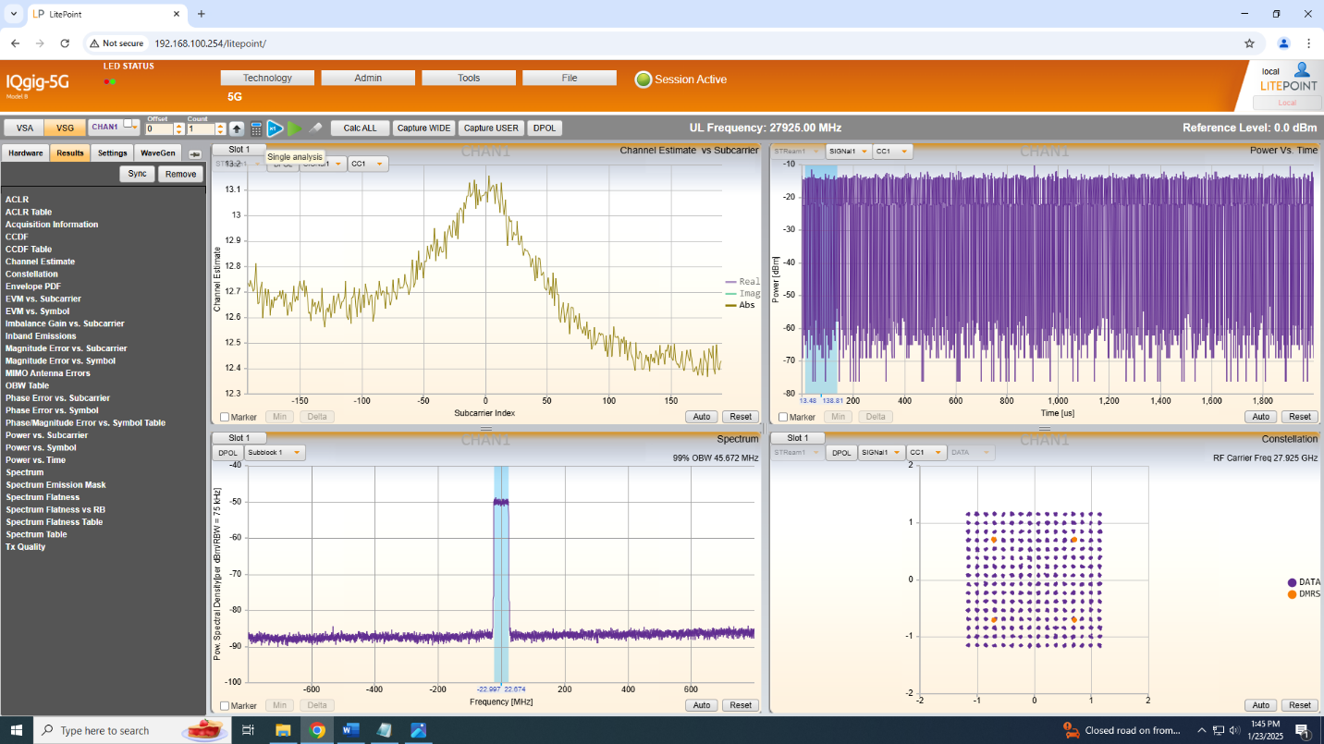

References
[1] IQgig-5G™ Model B. 5G mmWave Test System. Technical specifications. Litepoint, 2023. The pdf file is located n Canvas.

